3rd Grade Figurative Language

***Idioms***

An idiom or idiomatic expression refers to a construction or expression in one language that cannot be matched or directly translated word-for-word in another language. It is not literal.

Examples:

**She is green with envy.**

**It’s a piece of cake.**

3rd Grade Story Elements



***Setting MC900021382[2]***

The setting of a story is the place where the story happens and the time when it happens. The setting answers the questions of where and when. The setting doesn’t have to be a real time and place. It can be imaginary, like the island, Never land, in the story of Peter Pan.

3rd Grade Story Elements

***Character MC900441936[2]***

Every person or animal who takes part in the action of a story, poem or play is called a character. The most important characters are called major characters. Everyone else is a minor character. ***Character Traits*** A quality that a character exhibits is called a character trait. This trait can be indicated by the character's statements, actions, or thoughts.

***Conflict in Plot MC900312404[2]***

The plot iswhat happens, concretely, as though it were placed on a history time line. Conflict is essential to plot.  Without conflict there is no plot.  It is the opposition of forces which ties one incident to another and makes the plot move.

***Dialogue***  *MC900090375[2]*

Dialogue is a discussion or conversation between two or more characters.

3rd Grade Organizational Structures

MC900105198[2]***Chronological Order***

Chronological order presents ideas according to the time in which they occurred. This type of organization is especially effective if you are describing a process, relaying a series of actions, or telling a story. For instance, to convey the plot of a novel or the procedures of an experiment, you would tell readers what happened first, second, etc.

***Cause and Effect***

*Cause* is something that makes something else happen. Out of two events, it is the event that happens first. To determine the cause, ask the question "Why Did it Happen?" An *effect* is what happens as a result of the cause. Of two related events, it’s the one that happens second or last.  To determine the effect, ask the question "What Happened?"

**Poem** - is a written expression of emotion or ideas in an arrangement of words/verse most often rhythmically.

**Drama** is a literary composition involving conflict, action crisis and atmosphere designed to be acted by players on a stage before an audience.

3rd Grade Vocabulary Acquisition

***Root Word***

**Root word** is a word that has nothing added at the beginning or the end. It stands on its own as a word, it has a meaning. New words can be made from root words by adding beginnings (prefixes) and endings (suffixes).

***Prefix***

A prefix is a group of letters which you can add to the **beginning** of a root word**\*** to change the meaning of the word.  e.g. **mis** + fortune = **mis**fortune

| **Prefix** | **Meaning** |
| --- | --- |
| **mis** | means 'wrong' or 'badly' |
| **sub** | means under |
| **pre** | means 'before in time', 'in front of' or 'superior' |
| **un** | means not (there are also several other prefixes which mean not) |

***Suffix***

A suffix is a word ending. It is a group of letters you can add to the **end** of a root word**\*** **e.g.** walk**ing**, help**ful**

| **Suffix** | **Example** |
| --- | --- |
| **ed** | walk + ed = walk**ed** |
| **ing** | say + ing = say**ing** |
| **er** | tall + er = tall**er** |
| **tion** | educate + tion = educa**tion** |
| **sion** | divide + sion = divi**sion** |
| **fully** | hope + fully = hope**fully** |
| **est** | large + est = larg**est** |

3rd Grade Vocabulary Acquisition

***Antonym MC900441950[1]***

a word opposite in meaning to another. Fast is an antonym of slow.

***Synonym MC900290952[2]***

a word having [the](http://dictionary.reference.com/browse/the) same or nearly the same meaning as another in the language, as joyful, elated, glad.

***Homophone MC900384146[2]***

a word pronounced [the](http://dictionary.reference.com/browse/the) same as another but differing in meaning, whether spelled the same way or not, as heir  and air.

*Homograph *

A homograph is word that has the same spelling as another. Homographs differ from each other in meaning. Example: You will doubtless be annoyed if you tear your trousers while climbing over a fence. Indeed, you may be so upset that you shed a tear.

3rd Grade Conventions

|  |  |  |
| --- | --- | --- |
| Type of Sentence | Use | Punctuation Mark |
| Declarative | Makes a statement | Period          ( . ) |
| Interrogative | Asks a question | Question Mark          ( ? ) |
| Imperative | Gives a command or       makes a request | Period          ( . ) |
| Exclamatory | Expresses strong feeling | Exclamation Mark  **( ! )** |

3rd Grade Conventions  **Incomplete Sentences  Incomplete sentence**. Some sentences are incomplete because they lack either a subject or a verb, or both.. Examples: **Because his car was in the shop After the rain stops When you finally take the test**

**Verb Tenses **

An action which indicated a time of occurrence

Past: Already happened

Present: Is currently happening

Future: Will happen in the future

3rd Grade Conventions

**SIMPLE SENTENCE** A simple sentence, also called an independent clause, contains a subject and a verb, and it expresses a complete thought. Examples: **Some students like to study in the mornings. Juan and Arturo play football every afternoon. Alicia goes to the library and studies every day**.

**COMPOUND SENTENCE** A compound sentence contains two independent clauses joined by a coordinator. The coordinators are as follows: *for, and, nor, but, or, yet, so*. (Helpful hint: The first letter of each of the coordinators spells *FANBOYS*.) Examples: **I tried to speak Spanish, and my friend tried to speak English. Alejandro played football, so Maria went shopping.  Alejandro played football, for Maria went shopping**.

Print Features



3rd Grade Conventions

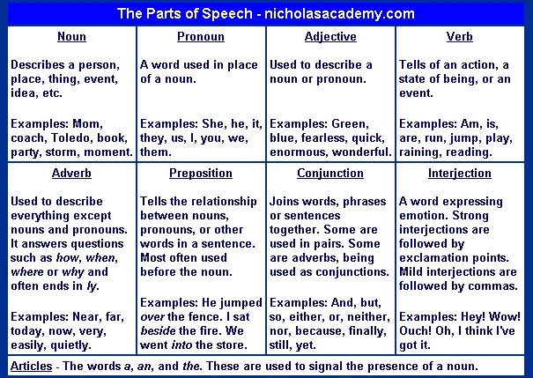

**MC900053159[1] Singular Noun:**  When a noun means one only, it is said to be singular.  Examples:  **boy, girl, book, church, box**

**MC900053159[1] MC900053159[1] Plural Nouns**- When a noun means more than one, it is said to be plural.  Examples:  **boys, girls, books, churches**

**Possessive Nouns** are used to show possession or ownership. They are words that would normally be nouns, but are used as adjectives to modify a noun or pronoun. Possessive nouns tell you who or what the modified noun or pronoun belongs to. **Dog’s collar**

MC900435448[2]

3rd Grade Sources

**Dictionary **  
 A **dictionary** provides information about the meaning, pronunciation, and spelling of words. **Guide words** appear at the top of each dictionary page. The word in the left corner is the first entry on the page and the word in the right corner is the last entry on the page. Guide words enable you to locate a word quickly.

**Thesaurus**  
A **thesaurus** contains synonyms for commonly used words. A thesaurus can help you precisely express your ideas when writing.

**Encyclopedia MC900013219[1]**   
An **encyclopedia** contains articles on a variety of subjects. The articles are written by experts on each of the subjects. In addition to articles, encyclopedias may include illustrations and diagrams, definitions of some words, and references to additional information.

MC900446256[2]